Mail Delivery Robot HOOLAKI: हुलाकी

Gaurav Shilpakar

Texas Tech University

May 2019

# Acknowledgment

I am very pleased to have received this opportunity of making this Mini Project run successfully. I would love to extend my sincere gratitude towards everybody who was a part of this project and to those who guided us throughout the four months process.

I want to thank our instructor Dr. David Hemmert for giving us an opportunity to push ourselves in a real-world-like project.

# Abstract

This paper deals with an autonomous mail delivery system based on Rover Tank Body and Basys3 Board. The system is composed of three subsystems. The motor system is based on L298n H-Bridge which makes the rover move along a metallic tape path using inductive proximity sensors. The infrared detection system composed of phototransistors with op-amps reads the frequency of the IR Light underneath each owner. Then the final system is the mail delivery system which consists of 3 servos with delivery arm. These three systems are collectively controlled by FPGA Diligent Basys3 Development Board.

# Table of Contents

Acknowledgment 2

Abstract 3

Table of Contents 4

Introduction 6

Hardware 6

Motor Control Unit 6

Line Tracking System 7

Current Protection Unit 9

Infrared Sensor Circuit 11

Mail Delivery System 14

Software 15

State Machine 15

Motor Movement 16

Infrared Detection 18

Servo Control Code 19

Results 21

Conclusion 22

Appendix-References 23

Appendix-Gantt Chart 25

List of Figures

[Figure 1 L298 Circuit Schematic for Bidirectional DC Motor 6](https://texastechuniversity-my.sharepoint.com/personal/gaurav_shilpakar_ttu_edu/Documents/Project%20Lab%201/Shilpakar%20Gaurav_Final%20Report%20xx.docx#_Toc8336538)

[Figure 2 Input States and Motor Functions 7](https://texastechuniversity-my.sharepoint.com/personal/gaurav_shilpakar_ttu_edu/Documents/Project%20Lab%201/Shilpakar%20Gaurav_Final%20Report%20xx.docx#_Toc8336539)

[Figure 3 Inductive Proximity Sensor 7](https://texastechuniversity-my.sharepoint.com/personal/gaurav_shilpakar_ttu_edu/Documents/Project%20Lab%201/Shilpakar%20Gaurav_Final%20Report%20xx.docx#_Toc8336540)

Figure 4 L78L33 Regulator Circuit 8

Figure 5 L78L33 Regulator Circuit Simulation 8

Figure 6 Current Protection Circuit 9

Figure 7 Current Protection Circuit Simulation 10

Figure 8 Phototransistor Circuit 11

Figure 9 Phototransistor Circuit Simulation 12

Figure 10 10 Hz Reading 13

Figure 11 100Hz Reading 13

Figure 12 1kHz Reading 13

Figure 13 Servo Claw Attachments 14

[Figure 14 Coding Flowchart 15](https://texastechuniversity-my.sharepoint.com/personal/gaurav_shilpakar_ttu_edu/Documents/Project%20Lab%201/Shilpakar%20Gaurav_Final%20Report%20xx.docx#_Toc8336551)

Figure 15 Motor Movement Flowchart 16

[Figure 16 Motor Movement Code 17](https://texastechuniversity-my.sharepoint.com/personal/gaurav_shilpakar_ttu_edu/Documents/Project%20Lab%201/Shilpakar%20Gaurav_Final%20Report%20xx.docx#_Toc8336553)

[Figure 17 Motor Simulation 17](https://texastechuniversity-my.sharepoint.com/personal/gaurav_shilpakar_ttu_edu/Documents/Project%20Lab%201/Shilpakar%20Gaurav_Final%20Report%20xx.docx#_Toc8336554)

Figure 18 Infrared Detection Code 18

Figure 19 Servo Control Flowchart 19

# Introduction

The objective of the project is to build an autonomous mail delivery system. It is based around Rover Tank Body and Basys3 Board. The rover follows a metallic tape path and delivers a single mail to three different recipients. The recipients are differentiated by the frequency of infrared light underneath the 6x3x6 inch box. Thus, the system is made up of three different sub-systems, motor control, IR detection, and mail delivery.

# Hardware

## Motor Control Unit

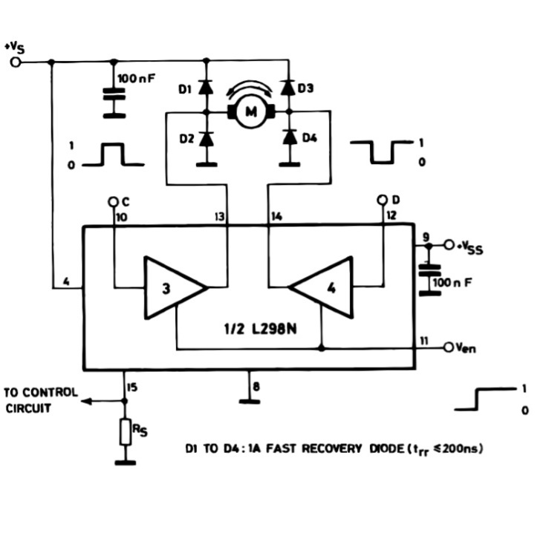The motors of the rover are driven by an L298N H-Bridge. It is a dual full bridge driver meaning it can power two different motors at the same time. It uses two different power supplies: one of 9.6V from the rover battery for the motor power and the other is a logic supply for the input pins of the motors.

Figure 1 L298 Circuit Schematic for Bidirectional DC Motor

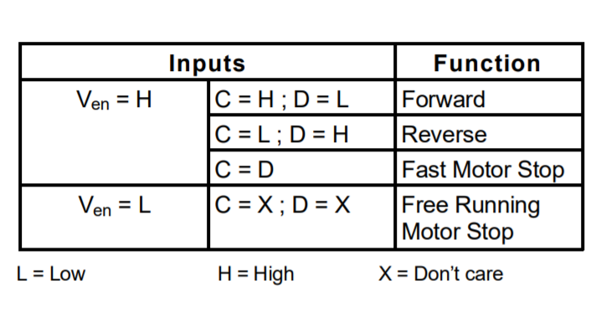The L298 H-Bridge has 3 different pins for a single motor: Enable, input 1 and input 2. Change of state in inputs 1 and 2 change the direction of the motor as shown by points C and D in fig. 2 and 3. The enable input state is controlled by a PWM Signal which in turn changes the speed of the motors.

Figure 2 Input States and Motor Functions

For the demo track, the PWM was adjusted such that there were no difficulties while making a turn. This was because, the rover usually stopped abruptly while making turns. Thus, the rovers were operated at 10kHz frequency with 60% duty cycle while moving forward and 90% for making turns.

## Line Tracking System

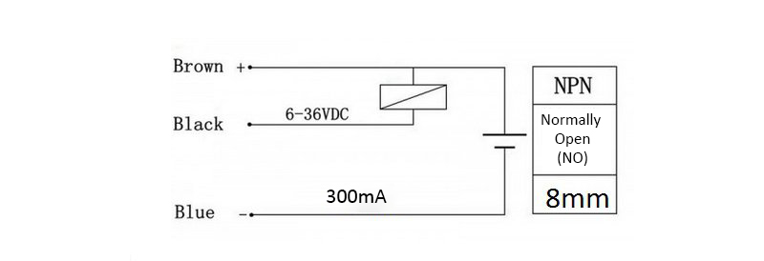For the rover to follow the metallic tape path, three inductive proximity sensors were used. The model of IPS used was LJ18A3-8-Z/BX. They are NPN Style Proximity Sensors. These sensors were placed on the front of the rover where the distance between each sensor was 2inches. As the sensor detected the metallic tape it gave an output low of 0V. Else it produced a high of Vcc equal to the 9V battery powering the four-proximity sensor.

Figure 3 Inductive Proximity Sensor

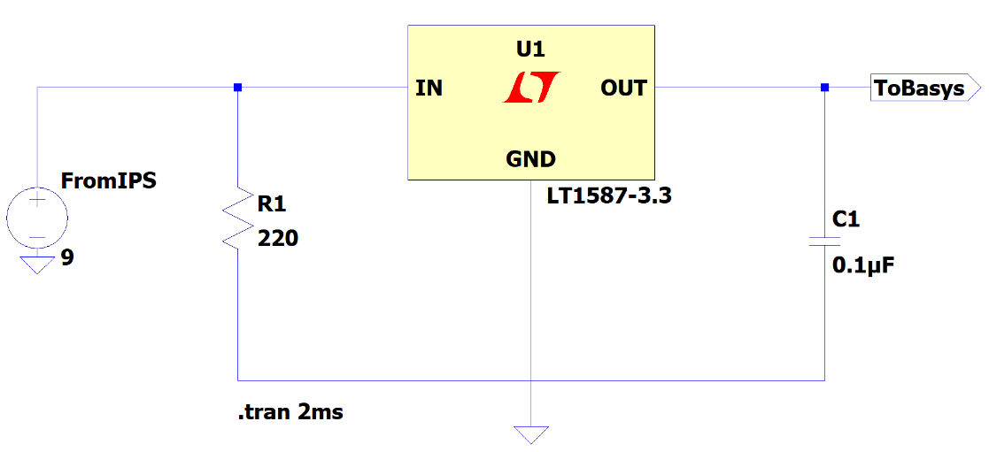Since the Basys3 can read voltages only up to 3.3V, a voltage regulator was used along the outputs of each of the proximity sensors. So, three L78L33 were used with three-proximity sensors. They are a three-terminal fixed voltage regulator. So, for an input voltage of 9V, input capacitor of 0.33uF, output capacitor of 0.1uF and input pull-up resistor of 220 Ohm, it gave an output of 3.25V. This is a permissible voltage for the Basys to read.

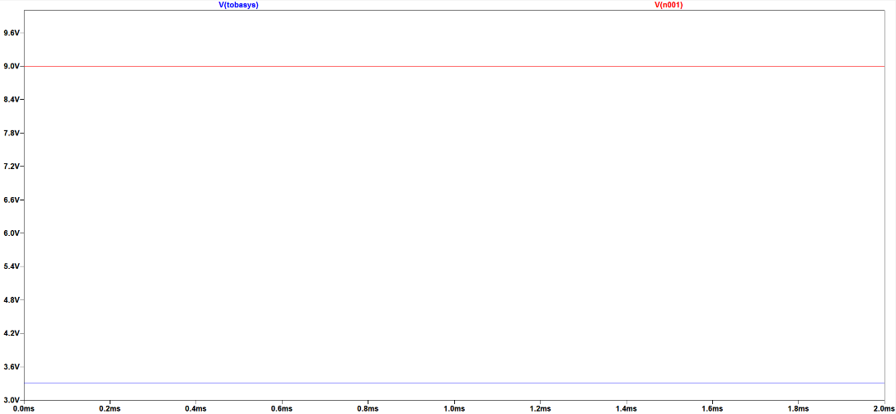Figure 4 L78L33 Regulator Circuit

Figure 5 L78L33 Regulator Circuit Simulation

The red line of 9V shows the input Vcc for the IPS. The blue line of 3.25V shows the regulated output for the BASYS.

## Current Protection Unit

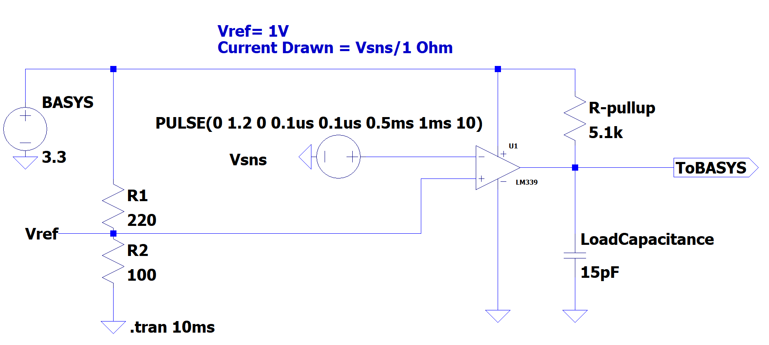To protect the rover motors from drawing more than 1A current, the comparator LM339 was used. It is a quad voltage differential comparator which compares the differential voltage of its input pins. It gives a logic low or high impedance based on the differential polarity. The sense pins on the L298N H-Bridge have an internal resistance of 1Ohm. Hence, the required 1V reference voltage is obtained across a 100 Ohm resistor from a voltage divider circuit of 100 and 220 Ohm as in fig. 6. Here, the input voltage of 3.3V is provided from the Basys3.

Figure 6 Current Protection Circuit

Based on the comparator schematic of fig. 6, a circuit was made. Through the circuit, a logic LOW was received when the current flow through the motors, as measured by the SNS pins, exceeded 1A. Then the BASYS 3 was used to stop the motors to avoid any damage.

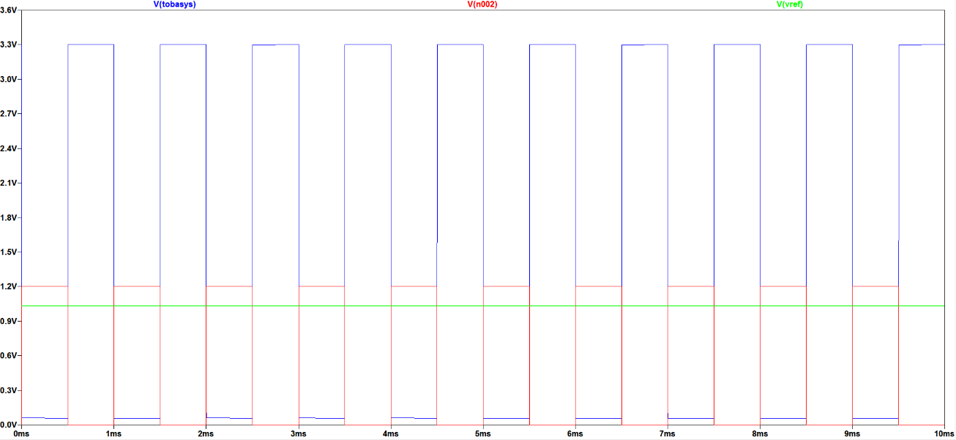

Figure 7 Current Protection Circuit Simulation

The figure 7 shows the simulated circuit for the current protection schematic. The green line for Vref shows the 1V reference voltage. The red square wave is a simulation of current drawn by the motors which is at 1kHz, 50% duty cycle. It peaks at 1.2V which simulates real life motors drawing above 1A current. Based on the simulation, the BASYS outputs a LOW whenever the current drawn is above the threshold of 1V denoted by the blue V(tobasys) square wave. Similar, a HIGH of 3.3V is received whenever the current drawn by the motors stay below 1V.

Upon testing the hardware and code for current protection, it was concluded that the motors never drew 1A of current. It peaked at 0.7V even when the rover was fully built with all the attachments and attempted to stop on the demo track. So, current protection wasn’t an issue for the project.

## Infrared Sensor Circuit

A basic phototransistor was used to detect the frequency of Infrared LEDs. The phototransistor used was TEKT5400s. Its wavelength detection range is 850 to 980nm and it covers an angle of 37 degree for IR reception. To amplify the range of detection of the IR sensor, an LM324 was used in non-inverting configuration. The schematic shown in fig 8 shows an amplification ratio of 100:1 but the real circuit used a ratio of 28:11 by using 5.6k and 220 Ohm resistors. From such configuration, IR signals were received from upto around 30 inches. The amplified signal from the LM324 was filtered using the LM339 comparator to get perfect square waves of the IR signal as shown in the circuit simulation fig 8. Two infrared sensors of the same configuration were made to be attached on two sides of the rover, right and left.

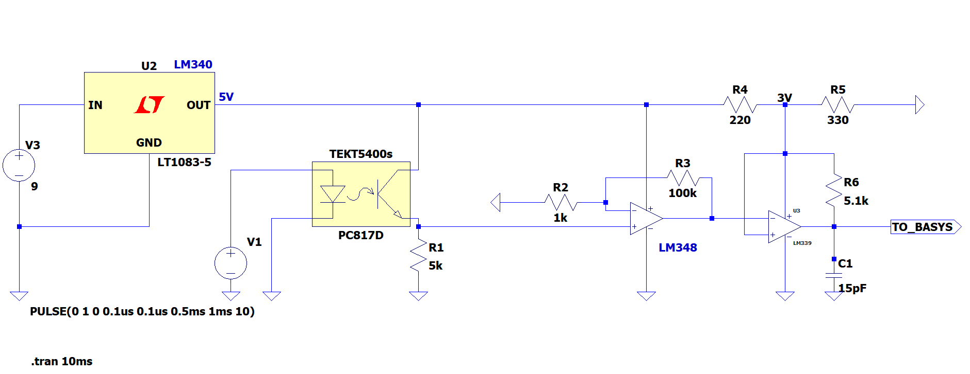

Figure 8 Phototransistor Circuit

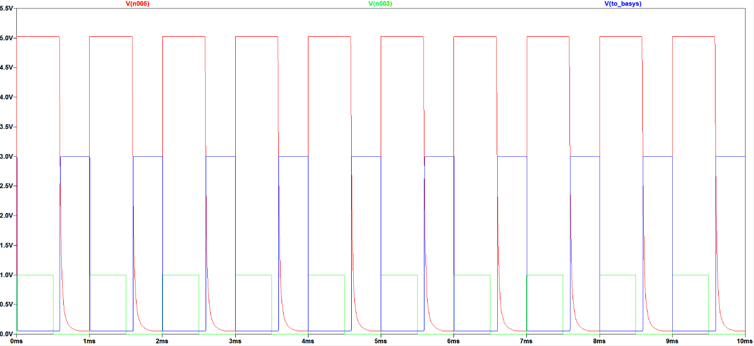

Figure 9 Phototransistor Circuit Simulation

In the simulation, the green square wave denotes the IR signal from the IR LED. Then it is amplified to a 5V peak to peak signal shown by the red square wave. Notice the curved edges on the falling clock cycle. Similar results were obtained on the real circuit. Then the filtered signal through the LM339 is denoted by the blue square wave which goes through a reverse biased 3.3V Zener Diode to limit the voltage going into the BASYS. The real data shown in figures 9 through 11 show the amplified (GREEN) and filtered (ORANGE) IR signals.

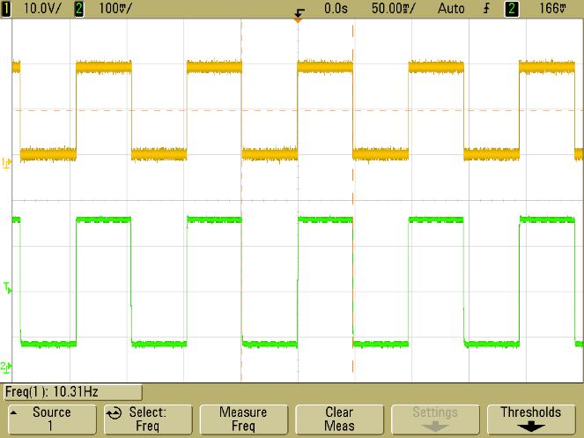

Besides, the IR receiver was enclosed in a tube made up of black electrical tape to prevent it from picking up IR signals from unwanted angles.

Also, falling edges of the amplified signals like the simulation were observed in the oscilloscope data. Such phenomenon is highly noticeable in the 1kHz data (Figure 12).

Figure 10 10 Hz Reading

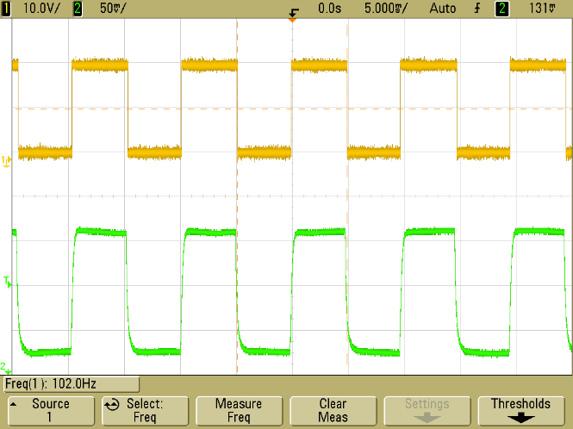

Figure 11 100Hz Reading

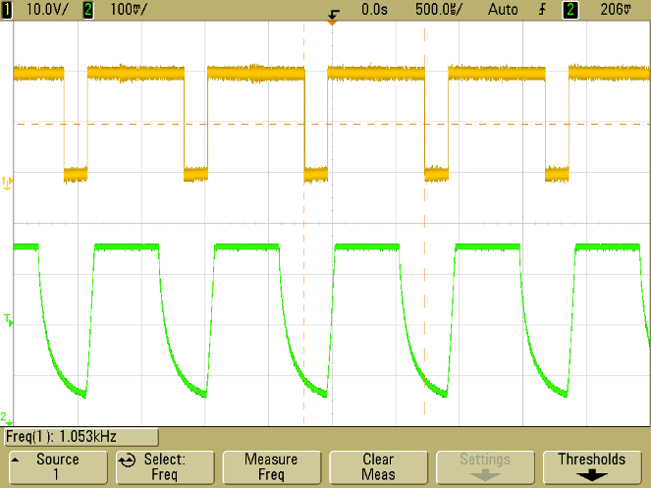

Figure 12 1kHz Reading

## Mail Delivery System

Initially, it was planned to use three micro-servo claws alongside two standard servos to deliver the mail. The two standard servos (HS-422) controlled the direction of mail delivery. It was built as shown in fig 13.

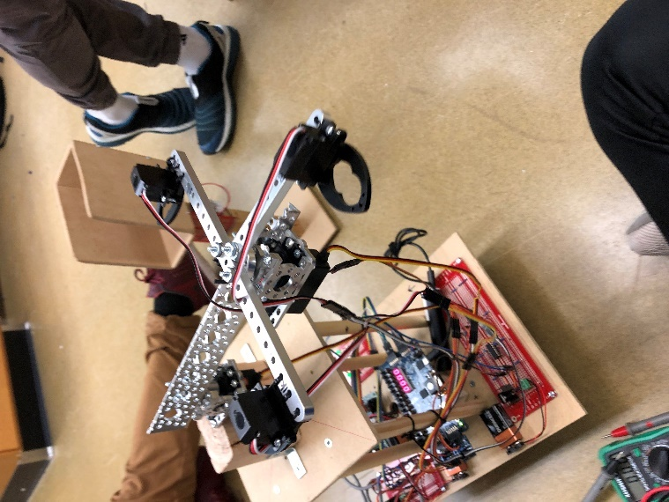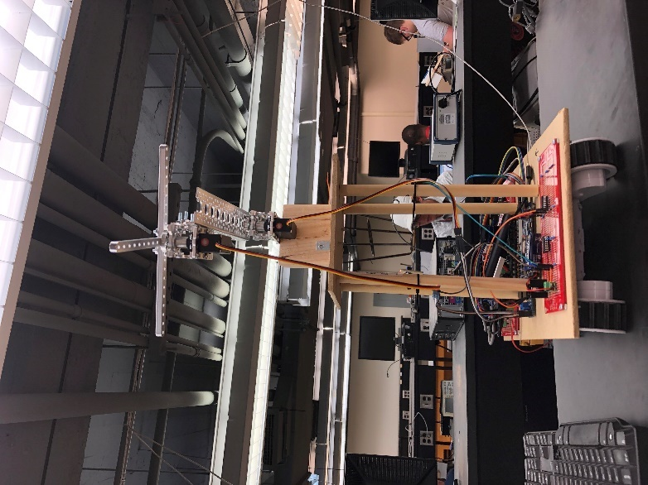

Figure 13 Servo Claw Attachments

Once an IR signal was detected, the respective claw was brought to front using the top servo. Then the lower servo rotated left or right based on direction of IR module triggered. After that the claw opened to deliver the mail. Unfortunately, this system failed due to limitations in time to work on the project. So alternate mail holders were made.

These holders were attached on top of the rover using three standard HS-422 servos. Each holder carried a unique mail, 10, 100 and 1kHz. The servos rotated +-90°. So, it was possible to deliver the mail on both sides of the rover.

# Software

## State Machine

A state machine is a method of system modeling in which the past inputs to the system determines the future state. The general flowchart for the system is as given in fig. 14. 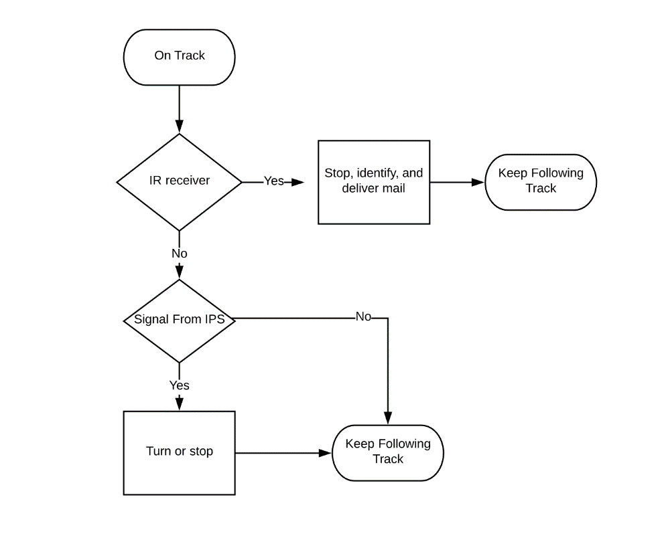

Figure 14 Coding Flowchart

From the state machine, highest priority is given to the signal from Infrared sensors and then to the IPS Sensors.

## Motor Movement

The movement of the rover depends on the state of the rover. The fig. 15 shows the current model of state machine for the motor movement.

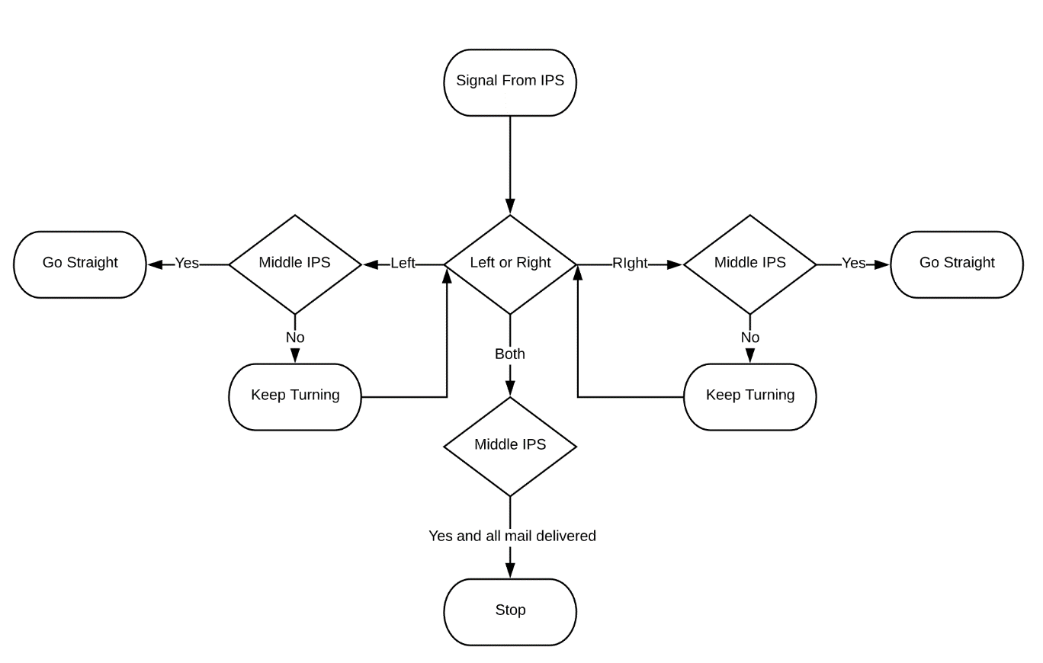

Figure 15 Motor Movement Flowchart

The state machine defines six possible states for the movement: **on_line**, **turnleft, turnright**, **beacon_found, overcurrent and deadend**. When the rover is in the state **on_line**, it just moves forward. **turnleft** and **turnright** makes the rover pivot in the respective direction until there is a signal from the middle IPS. When the rover detects an IR signal, it goes into **beacon_found** state. It stops the rover and continues its path after delivering the mail. **deadend** state is triggered when all the mails are delivered and then there is a signal from all three IPS. This makes the rover stop on the straight line. The **overcurrent** is a state where the rovers draws over 1Amp current. This stops the rover for 2seconds and attempts to run again. The state changes to **on_line** as the current drawn is regulated to lower than 1A.

Figure 16 Motor Movement Code

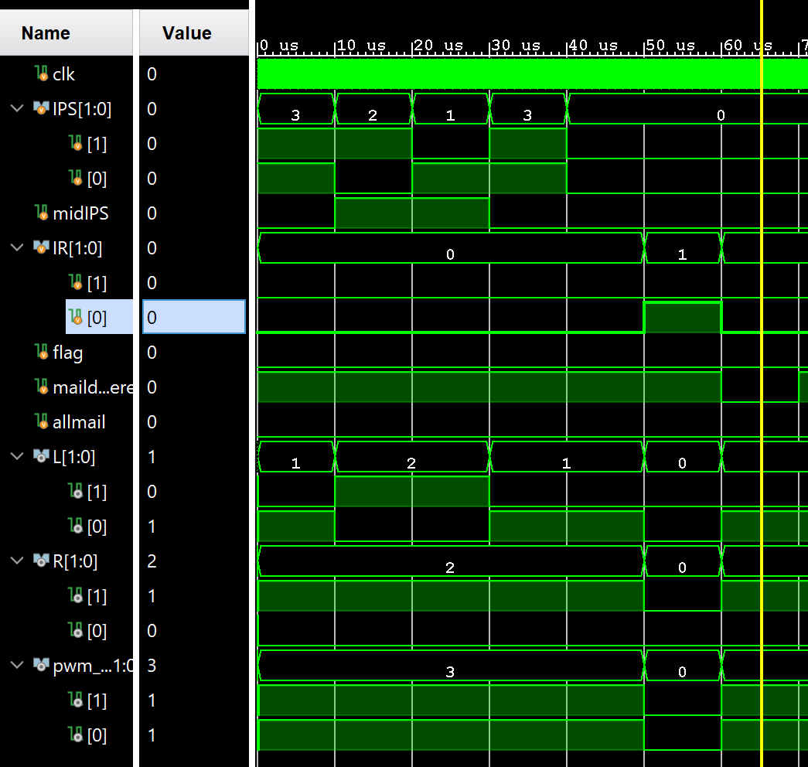

Figure 17 Motor Simulation

## Infrared Detection

The detection of the infrared frequency is done on software level using the Basys Board. Use of different band pass filters for three different frequencies of the IR was avoided. The amplified signal from the phototransistor is plugged into BASYS which the counts the posedges in the given port for one second. This is equivalent to counting for 100 Million-1 with the positive edge of clock as the internal clock has a frequency of 100 Million Hz. Then the counted data is stored in another register which is then compared to the three given frequencies: 10, 100 or 1000Hz. This data is then it is displayed in the 7- segment display.

Figure 18 Infrared Detection Code

## Servo Control Code

Figure 19 shows the flowchart for the servo control after the detection of infrared signal.

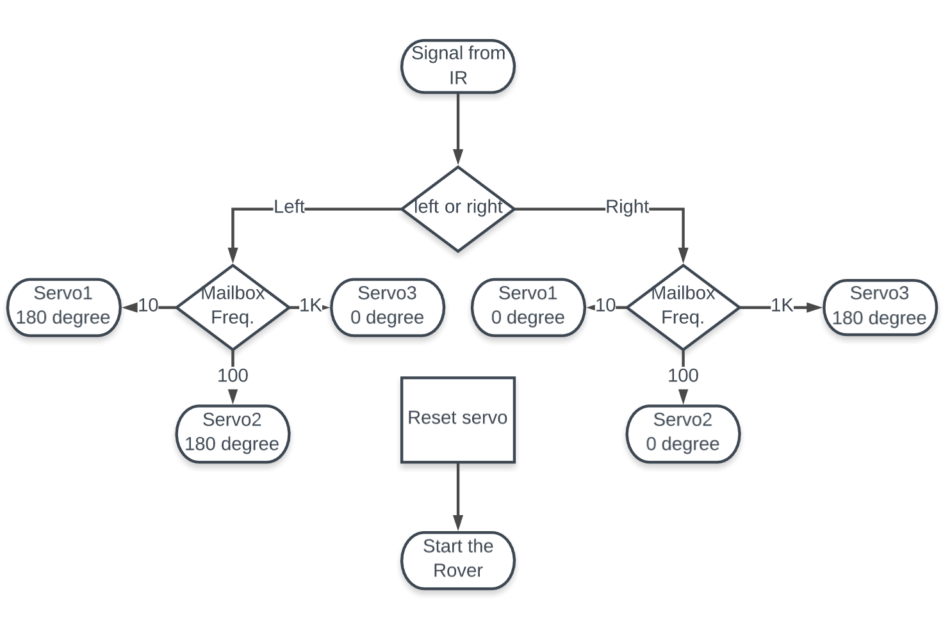

Figure 19 Servo Control Flowchart

The servo 3 for the 1kHz mail, has inverted movement since it was attached opposite to the rest two servos. When the rover detects the IR, it triggers the servo as per the frequency and makes either a 0 or 180 drop according to the side of the IR module triggered. Then a delay of 1sec is created which resets the servo to its original state and then sets the state to on_line again.

BASYS 3 Control Unit

The BASYS 3 is an FPGA development board featuring Xilinx Artix-7 FPGA architecture which uses Vivado Design Suite. It was used as the main control unit of our project. It consists of 4 PMOD ports each consisting of 12 pins.

The JA PMOD were used for motor control. The JB PMOD were used for servo control using an external PMOD connector. The JAXDC PMOD were used for the 3 inductive proximity sensors, 2 current protection inputs, and 2 infrared modules. Also, the seven-segment display on the BASYS board was used to display the frequency of the infrared LED detected.

# Results

All the hardware and software components were combined and tested numerous times. The infrared detection system worked perfectly fine, but it picked up signals from a wide range which caused the rover to stop on the track randomly. Then it required a constant IR signal to continue its journey. Also, the friction between the rover and the demo track was large which cause the rover to stop abruptly sometimes during turns. This was solved by raising the PWM of the motors. Hence, the rover tracked the metallic tape, detected the infrared signals and delivered the necessary mail.

# Conclusion

Thus, all the required tasks were completed successfully and on time as well. So, all the requirements of the project were fulfilled. Thus, Hoolaki successfully delivered the specific mail for the set mailbox.

# Appendix-References

This Appendix includes the list of references used for any systems in the report.

1. L298 Datasheet: <https://www.sparkfun.com/datasheets/Robotics/L298_H_Bridge.pdf>
2. Rover 5 Robot Platform: <https://www.sparkfun.com/products/10336>
3. BASYS 3 FPGA: <https://reference.digilentinc.com/_media/basys3:basys3_rm.pdf>
4. LM339 Datasheet: <http://www.ti.com/lit/ds/symlink/lm2901.pdf>
5. L78L33 Datasheet: <https://www.mouser.com/datasheet/2/389/l78l-974102.pdf>
6. LM324 Datasheet <http://www.ti.com/lit/ds/symlink/lm324-n.pdf>

Appendix-Budget

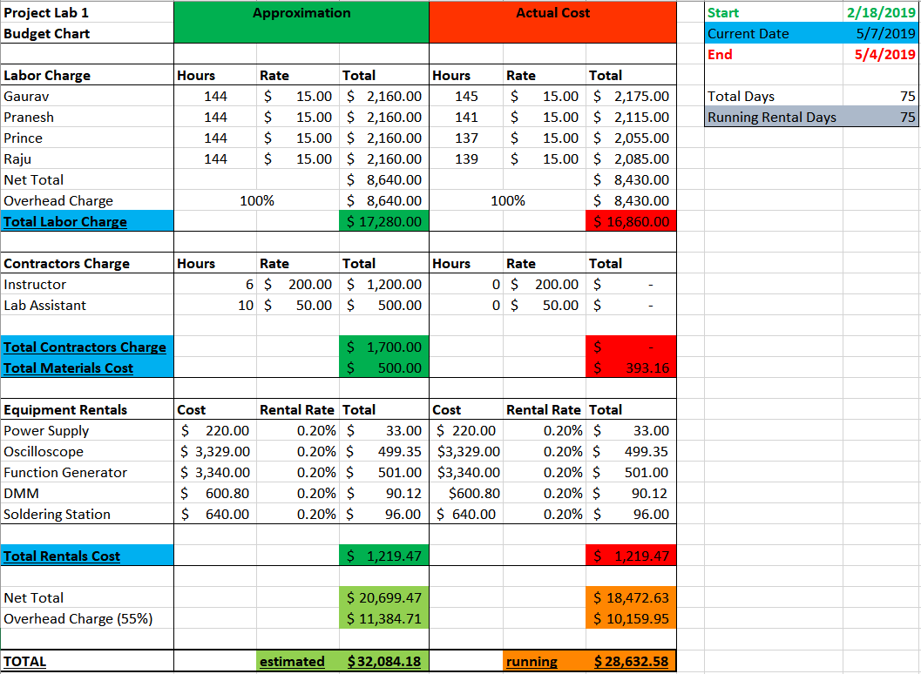

The green side of the Budget chart shows us the estimation that was made at the start of the project. The red side is the actual expenses made during the project.

The budget sheet shows that the project was fairly completed under the budget. No contract labor was used during the project. It has been a major part of savings. Hence, we came right under the estimated budget after the completion.

# Appendix-Gantt Chart

From the Gantt Chart posted, most of the scheduled tasks look to be completed on time. There was a delay on the mail delivery part as mentioned before in the report. But overall, everything completed on schedule which resulted in a successful project.